Full Paper Title in Title Case (Century School 18 bold)

First Author¹, Second Author² and Third Author³
¹ Full address of first author, including affiliation and email
² Full address of second author, including affiliation and email
³ Full address of third author, including affiliation and email

ABSTRACT
This file provides a template for writing papers for the Final Edited Proceedings IC2EM-2018 Conference. The conference proceedings will be published in an electronic format. The full paper file shall be written in compliance with these instructions. The author is asked to submit the paper in PDF Format (Standard). Four hardcopy of the Final Proceedings will be remitted to the National Library of Algeria for long time conservation.
An abstract not exceeding 500 words, in English, should appear on the top of the first page, after the title of the paper in chapter titled "Abstract" (without chapter number), after the names of the authors and the contact information of the corresponding author.
Key Words: Maximum 5 Key words.

1. INTRODUCTION
It is expected that authors will submit carefully written and proofread paper. Spelling and grammatical errors, as well as language usage problems, are not acceptable in the final submission. There is no strict limitation to the number of pages, but it is suggested that the paper length should not exceed 12 pages.
Papers should clearly describe the background of the subject, the authors work, including the methods used, and concluding discussion on the importance of the work. Papers are to be prepared in English (British or American). Technical terms should be explained. Acronyms should be written out at their first appearance.

2. SUBMITTING THE Paper
The Full paper has to be submitted electronically via Easy Chair Platform. Final-Proceedings.

3. paper format
The uniform outlook will help the reader to follow the proceedings. This can be obtained most easily if authors use this template file to construct their papers. Please note the following details: this template is an A4 format 2cm margins Top-Bottom and Left-Right. All text paragraphs should be single spaced, with 6pt spacing used after headings and subheadings as shown in this example. Position and style of headings and subheadings should follow this example. One space should be placed between paragraphs. Please do not change any of the above mentioned page, paragraph and font settings.

3.1. Fonts
Papers should use 11-point Century School font. It is recommended that text in figures is not smaller than 10-point font size. Please follow exactly font dimension of this template.

3.2. Tables and Figures
Figure captions and table headings should be sufficient to explain the figure or table without needing to refer to the text. Figures and tables not cited in the text should not be presented. Styles Heading Table and Caption Figure are available in this template for tables and figures. The following is the example for Table.1.
Table.1 Performances summary of the proposed amplifier
Tech.  ($μm$) | C_{PD}  ($pF$) | BP  ($GHz$) | Gain  ($dBΩ$) | Noise  (${pA}/{\sqrt{Hz}}$) | Power  ($mW$)
0.35 | 1.5 | 1.90 | 65.0 | 9.7 | 17
0.50 | 0.6 | 1.20 | 64.0 | 0.6 | 115
0.18 | 0.2 | 1.80 | 58.7 | 13.0 | 47

Tables and figures should be placed close after their first reference in the text. All figures and tables should be numbered with Arabic numerals. Table headings should be above the tables. Figure captions should be centred below the figures. Minimum figures’ resolution: 600dpi. Please avoid figures from the internet without permission. The following is the example for Figure.1.

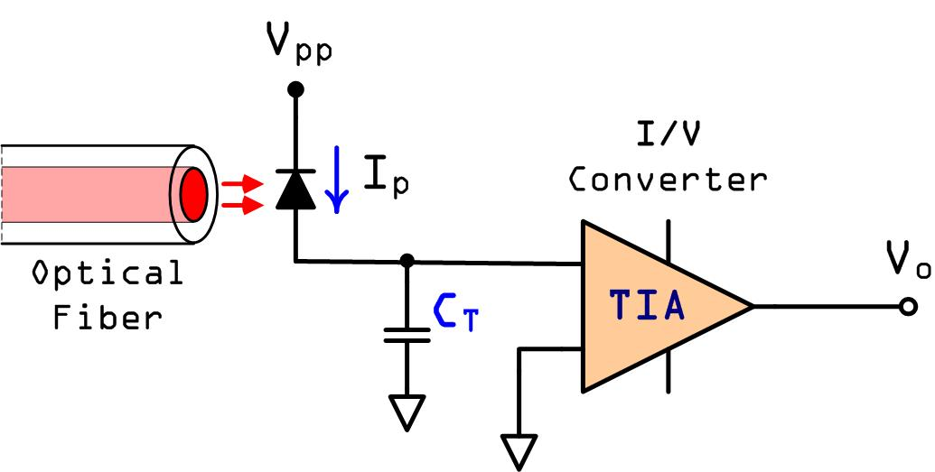
Figure.1: 30 The principle of transimpedance (TIA) amplifier

3.2. Equations
Equation must be written with Word Math Editor or MathType. Equations must numbered and cited in the text.
$R\left(t\right)=1-e^{-λt}$ (1)
$F\left(t\right)=1-R\left(t\right)=e^{-λt}$ (2)

ACKOWLEDGEMENTS
This work was supported by the PNR Projet entitled: Développement d’une Instrumentation pour le Diagnostic et la Prévention du Mal Perforant Plantaire chez le Diabétique under the supervision of ATRSS (Agence Thématique de Recherche en Sciences de la Santé, https://www.atrss.dz). Also, many thanks to the DGRSDT (Direction Générale de la Recherche Scientifique et du Développement Technologique, http://www.nasr.dz) for their supports and funding the INSEM team.

REFERENCES
[1] Boukhenous. S, Benbakhti. A, Touchen. A and Attari. M “ A 2 DOF Platform For Ankle Sprain Rehabilitation.” 2013 International Conference on Electronics, Computer and Computation (ICECCO), Athens, Greece, City , pp. 25-27, 2013.
[2] Wong, W.Y.; Wong, M.S., “Detecting spinal posture change in sittingpositions with tri-axial accelerometers,” Gait & Posture, 2008, 27, 168-171.
[3] Dune, L.E.; Walsh, P; Hermann, S.; Smyth, B., and Caulfield, B. ‘‘Wearable Monitoring of Seated Spinal Posture,’’ IEEE Transactions on Biomedical Circuits and Systems, 2008, 2, 2, 97-105.
[4] Jeong, D.U.; Do, K.H.; Chung, W.Y. ‘‘Implementation of the Wireless Activity Monitoring System Using Accelerometer and Fuzzy Classifier,’’ International Journal of Information Systems for Logistics and Management, 2008, 3, 2, 115-120.
[5] Kitamura. S, Sagawa. K, Tsukamoto. T and Ishibashi. Y, “Development of a Wireless Inertial Measurement System for Pitching Motion Analysis,” Advanced Engineering Forum, Vols. 2 3, pp. 452-457, 12, 2011.
[6] Takeda. R, Tadano. S, Natorigawa. A, Todoh. M and Yoshinari. S, “Gait posture estimation using wearable acceleration and gyro sensors,” Journal of Biomechanics, Vol. 42, No. 15, pp. 2486-2494, 2009.

NOTES
- The header must be only in the first page.
- Do not use foot not.
- Do not numbered pages.
- Do not add authors’ biographies.

